# User Guide for the Global Migration Health Training and Resource Repository

## Title Page

**Project Name**: Development of a Global Migration Health Training and Resource Repository: Enhancing Access, Collaboration, and Capacity Building

**Document Name**: User Guide for the Global Migration Health Training and Resource Repository

**Date**: 9/01/2024

**Prepared by**: Craig Parker, Kuda Mbata and Rebecca Walker,

**Prepared for** the MHADRI Leadership Team

Contents

User Guide for the Global Migration Health Training and Resource Repository 1

Title Page 1

Introduction 3

Getting Started 3

User Dashboard/Interface 3

Navigating the Website 3

Using and Updating the Database 4

Adding and Editing Entries 5

Data Accuracy 5

Managing Content 5

Uploading Content 5

Content Management System (CMS) 5

Technical Specifications 5

Homepage Overview 5

Search Trainings/Courses Page Overview 9

Updating the database: 11

Mobile Interface Navigation 15

Accessing the Repository 15

Home Page 15

About the Repository 15

Interactive Map 15

Using the Search Function 15

Definitions/Set of Criteria 16

Filtering Options 16

Course Listings 16

Downloading Data 16

Footer and Additional Navigation 16

Responsive Design Considerations 16

Frequently Asked Questions (FAQs) 16

## Introduction

Welcome to the Global Migration Health Training and Resource Repository, an initiative to enhance access to migration health training resources and foster global collaboration. This user guide is designed to assist you in navigating and utilising the repository to its full potential. Within these pages, you will find a comprehensive overview of the website's features and step-by-step instructions for managing content, ensuring you can contribute to and benefit from this platform effectively.

## Getting Started

### Accessing the Website

To access the website, enter the provided URL into your web browser. The website is accessible on most devices and web browsers for your convenience. The website address will become clearer once a serving platform is decided upon.

### User Dashboard/Interface

You will be directed to your user dashboard (Figure 1), which provides a personalised overview of available resources, your saved courses, and quick access to key sections of the website.

##### Figure 1: User dashboard

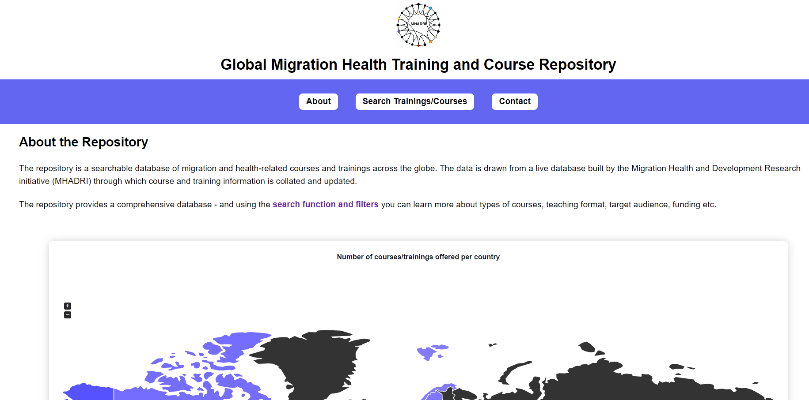

## 

## Navigating the Website

The structure of the repository aims to offer a seamless user experience. The homepage provides the gateway to the various key sections of the repository: About, Search Trainings/Courses, and Contact (see Figure 2).

Clicking on each of these will take you to more information and further links. You can also utilise the interactive maps and search functionalities for a fast and easy exploration of the training and courses relevant to your interests.

Whether you're a seasoned researcher or a new user, navigating our website is straightforward. If you ever need to return to the homepage, simply click the 'home' icon located in the upper left corner of every page.

Figure 2 (Key sections of homepage)



## 

## Using and Updating the Database

### Accessing the Database

The database can be accessed directly through the website’s 'Search Trainings/Courses' section. Here, you can view the full range of resources available (Figure 3)

##### Figure 3: Global map

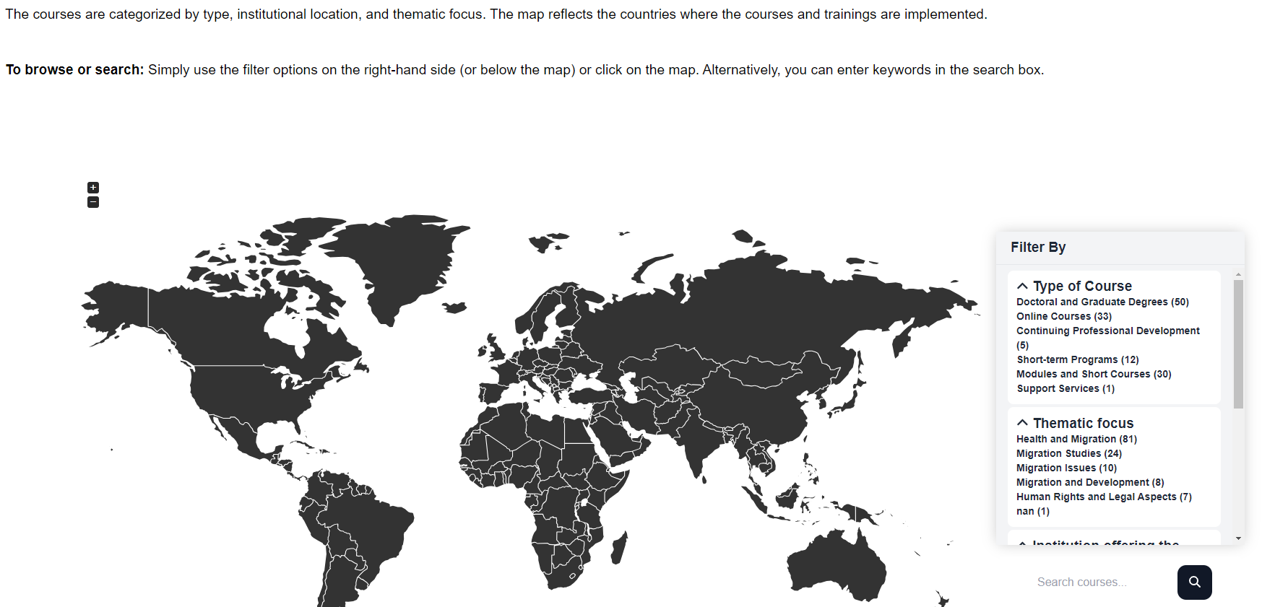

### Viewing and Searching Data

For specific queries and to view courses you can browse the listings or use the search bar. Filters are available to refine your search using criteria such as course type or location – see Figure 4 below.

##### Figure 4: Search filters

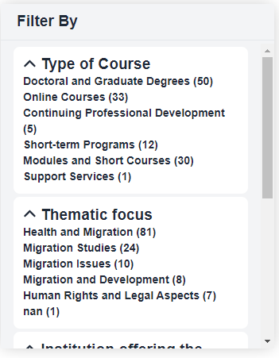

### Adding and Editing Entries

Authorised users can add or edit database entries through the Django admin panel, accessible at **https://[backend-url]/admin/**. Ensure you have the correct permissions before attempting to make changes.

### Data Accuracy

When adding or editing entries, double-check all information for accuracy. Consistency in data entry is crucial for maintaining the integrity of the database.

## Managing Content

### Uploading Content

To upload content, navigate to the admin panel or the relevant section in the user dashboard. Follow the on-screen instructions to add new files, ensuring they meet the specified format and size limitations.

### Content Management System (CMS)

The backend CMS can be used for detailed content management. This guide provides instructions specific to the CMS in use, including how to update or remove existing content.

### Technical Specifications

Be mindful of the technical specifications for uploads, including acceptable file formats and size limitations, to ensure compatibility and accessibility.

## Homepage Overview

### 5.1 Home Page Overview and detailed walkthrough

* **Header**: Showcases the repository's title, highlighting its global scope and focus on migration health training and resources.
* **Navigation Bar**: Presents three primary options—About, Search Trainings/Courses, and Contact—each leading to a dedicated website section.

##### Figure 4: Homepage

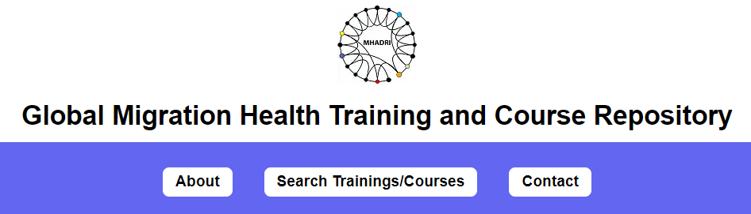

* **About the Repository Section**: Details the repository's role as a centralised database for course and training information, highlighting its search capabilities and filters.
* **Search Function and Filters**: Explains how users can utilise the search function and apply filters like Type of Course, Thematic Focus, Population Focus, and Funding/Grants Availability to find relevant courses.

### 5.1 Using the Interactive Map

Our interactive map is a visual treasure trove of global data. To uncover the insights it holds, simply click on any country. A detailed pie chart will then appear, showcasing the distribution of teaching methods or course types specific to that region.

**Navigating the Map:**

1. **Zoom and Pan:** To focus on a specific region, use your mouse or touchpad to zoom and pan across the map.
2. **Country Selection:** Click on a country, like South Africa, to drill down into detailed educational data for that location

##### Figure 5: Interactive map

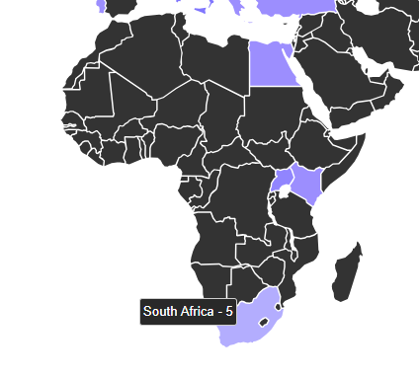

* **Understanding the Map**: Describes the interactive map that visualises the global reach of the repository's listings.
* **Interaction with the Map**: Provides instructions on interacting with the map, including selecting countries to view available courses and the types of teaching mechanisms used.

**Figure 6: Country-Specific Data Visualization - Teaching Mechanisms**

When you select a country, the map interface will dynamically update to show a pie chart reflecting various teaching mechanisms used within that country, such as 'Face to Face' or 'Online' methods. This visual tool helps to quickly assess the educational approaches prevalent in the selected region.

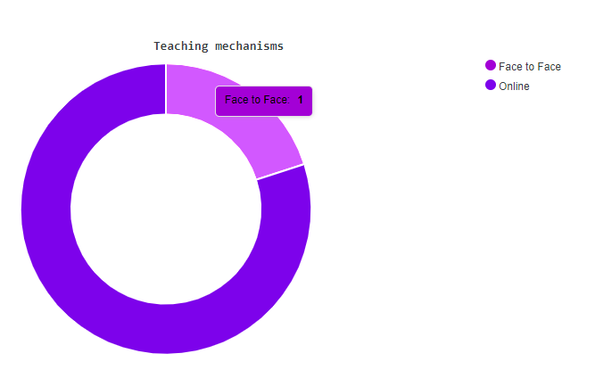

**Figure 7: Comparative Analysis by Teaching Method**

This figure represents the distribution of teaching methods for a selected country or region when compared to others. By hovering over the segments, you can view the number of instances for each teaching method.

**Figure 8: Course Types Distribution**

Upon clicking on a country, you will see a breakdown of the types of courses offered, such as 'Doctoral and Graduate Degrees' versus 'Modules and Short Courses'. This allows for an immediate understanding of the higher education structure within the selected area

### 5.2 Definitions / Set of Criteria

* **Clarifying Terminology**: Offers definitions for terms such as Institution, Institution Location, Type of Course, and more, ensuring users understand the criteria used within the database.
* **Applying Criteria**: Guides users on how these definitions apply when searching and filtering the database.

##### **Figure 10**: Definitions/Criteria

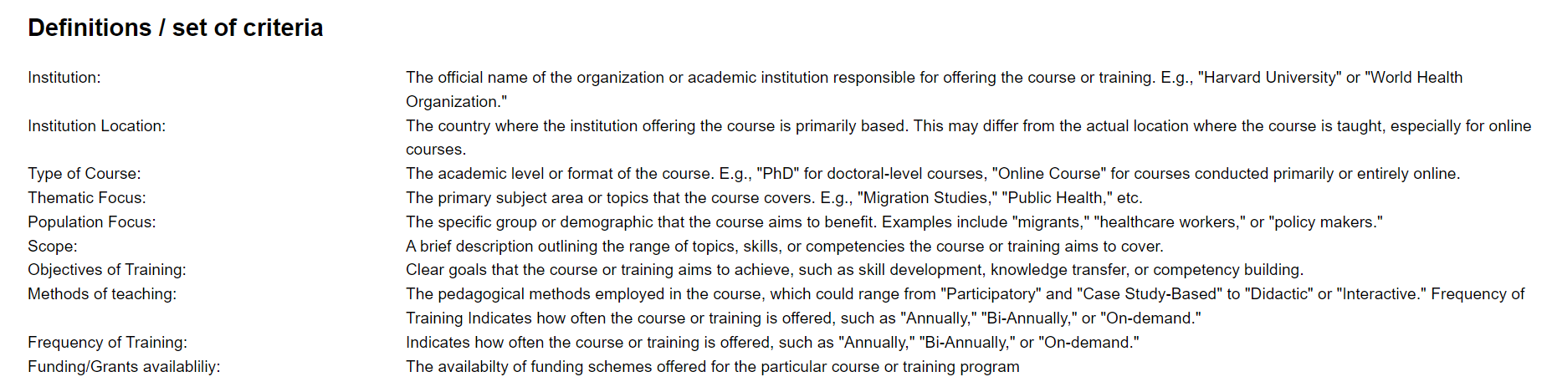

About MHADRI

* **Mission Statement**: Outlines the aims of MHADRI to advance evidence-informed global migration health policies and practices.

Contacting the Repository

* **Footer Section**: Directs users to additional information about MHADRI, including how to get involved and contact details.

Footer

* **Copyright and Navigation**: Indicates copyright information and provides additional navigation links to About MHADRI, Steering Committee, Early Career Researchers, Get Involved, and Contact sections.

##### Figure 11: Pop Up Information Box

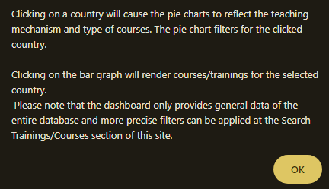

Pop-Up Information Box

* **Interactive Guide**: Includes an explanation of the pop-up information box that appears when interacting with the map, which offers guidance on interpreting the data visualisations such as pie charts and bar graphs for each country.

## 

## Search Trainings/Courses Page Overview

Introduction

* This user guide section focuses on the "Search Trainings/Courses" page of the Global Migration Health Training and Course Repository.
* The page provides an interactive map and filtering options to help users find courses and trainings based on type, location, and thematic focus.

### 6.1 Interactive Map and Search Functionality

* **Interactive Map**: A visual tool that shows the geographical distribution of courses. Users can click on countries to filter courses by location.

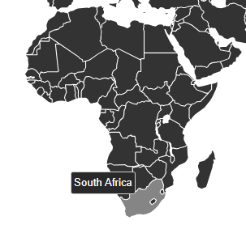

* **Search Box**: Allows users to search for courses directly by entering keywords related to their interests.

Filter Options

* **Types of Courses**: Users can filter results by course type, such as modules and short courses, doctoral degrees, and graduate degrees.
* **Thematic Focus**: Filters allow users to narrow courses by themes like Human Rights, Health and Migration, and Migration Studies.
* **Institution Offering the Course**: Users can select courses based on the institutions offering them, such as the Centre for Human Rights at the University of Pretoria or Wits University.



### 6.2 Course Listings and Details

* Each course listing provides a snapshot of key information:
  + The name of the institution offering the course.
  + The type of course offered.
  + The teaching mechanism (e.g., online, face-to-face).
  + The last update date to ensure users have the latest information.
* **Read More**: Clicking on this link takes the user to a more detailed page about the course, providing extensive information on course content, structure, and enrolment.

##### Figure 12: Course information

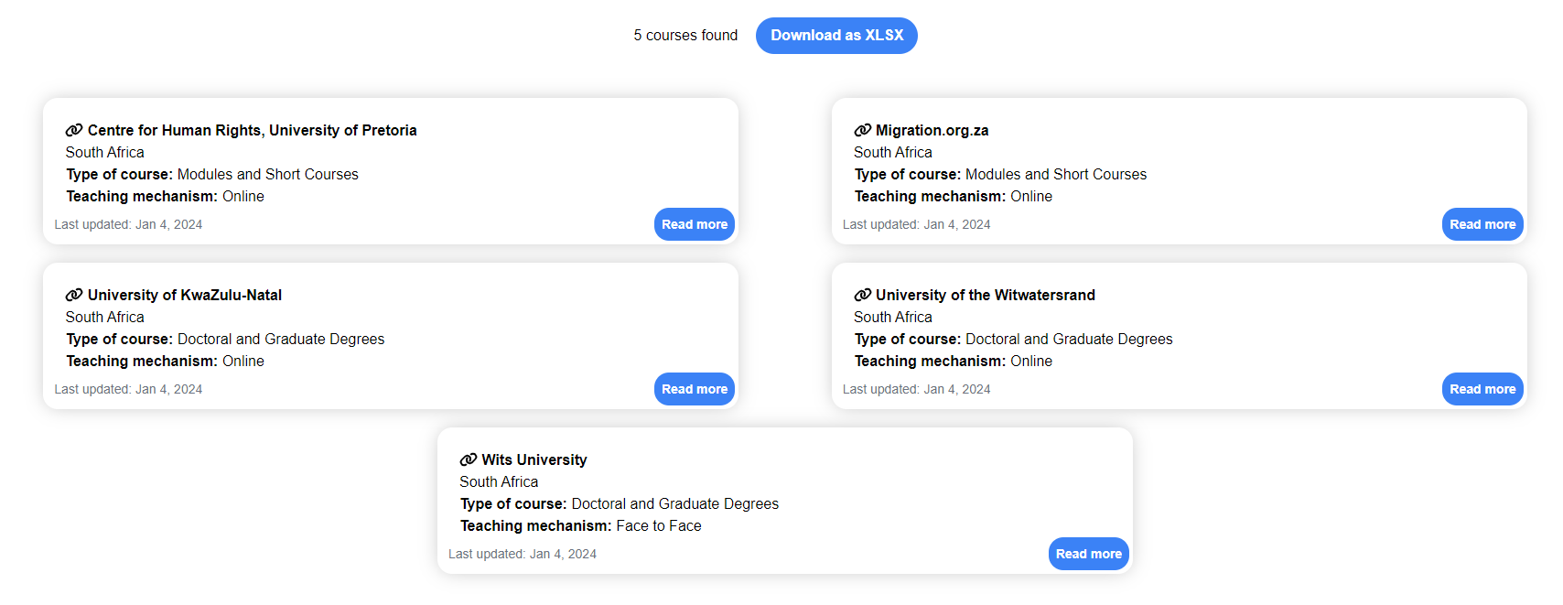

### 6.3 Downloading Course Information

* Users can download the list of courses as an Excel file, offering offline access and the ability to perform additional analysis or record-keeping.

 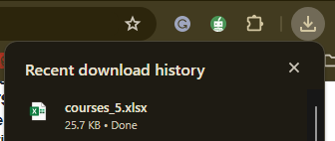

Footer and Navigation

I

* The footer repeats the mission statement of MHADRI and offers navigational links to other sections of the website, including the About page and options to get involved with MHADRI.

##### Figure 13: About MHADRI

Navigational Links

* **About**: Redirects to a page detailing the organisation’s goals, history, and structure.
* **Steering Committee**: Information about the leadership team and their roles within MHADRI.
* **Early Career Researchers**: Provides resources and networking opportunities for newcomers to the field of migration health research.
* **Get Involved!**: Lists ways for individuals and institutions to contribute to and participate in MHADRI’s activities.[1]
* **Contact**: Connects users with MHADRI for inquiries, support, or collaboration proposals.

## Updating the database:

Below are the steps required for authorised persons to maintain and update the database.

1. **Access the Admin Interface**:
   * To update the database, any authorised user will need to navigate to the admin interface of the Django backend. This is typically done by going to the **/admin/** path of the website. In this case, the URL to access the admin interface would be `https://mhadriri-final-database-af023718fb18.herokuapp.com/admin/
2. **Log In**:
   * Upon reaching the admin login page, the credentials of the authorised persons should be entered. These should be a username and a password that has been previously set up when the Django admin was configured.

##### Figure 14: Administration access

1. **Navigate the Admin Dashboard**:
   * After logging in, the authorised person will be taken to the admin dashboard. Here, they will see a list of models that have been registered with the admin interface. Each model corresponds to a table in the database.

Figure 15: Django Administration 1

1. **Add or Edit Entries**:
   * To add a new entry, the authorised person will click on the model representing the data they want to add and then click on the "Add" button.
   * To edit an existing entry, they will click on the model and then click on the entry they wish to edit from the list displayed.

Figure 16. Django Administration 2

##### Figure 17: Django Administration 3

1. **Fill Out the Form**:
   * Whether adding a new entry or editing an existing one, the authorised user will be presented with a form where they can input the relevant data. Required fields are usually marked and need to be filled out for the form to be saved.

##### Figure 18: Django Administration 4

1. **Save the Changes**:
   * After inputting the necessary data, The authorised user will click the "Save" button at the bottom of the form. This action commits the changes to the database.
2. **Delete Entries**:
   * If The authorised user needs to delete an entry, they can select the entry from the list in the model's page and choose the delete option, usually available as a button or a link. She will be asked to confirm the deletion before it is permanently removed from the database.
3. **Log Out**:
   * Once all necessary updates have been made, The authorised user should log out of the admin interface to prevent unauthorized access, especially if they use a shared or public computer.

It's important to note that for changes to take effect, The authorised user must have the proper permissions set within Django’s admin interface. If they encounter any issues, they may need to contact the development team to ensure the user account has the necessary permissions or if there are any specific workflows to follow.

Finally, it should be noted that the Django admin interface is a powerful feature that allows for easy management of the database contents without directly interacting with the database itself or writing any SQL queries. However, with this power comes the responsibility to ensure that changes are made carefully to maintain the integrity of the data.

## Mobile Interface Navigation

The Global Migration Health Training and Course Repository is fully accessible on mobile devices, offering a responsive and user-friendly experience.

The mobile interface is designed with responsiveness in mind, ensuring that buttons, text, and interactive elements are easily clickable and legible on smaller screens. If any part of the page is not displaying correctly, ensure that your mobile browser is up to date or try rotating your device to landscape mode for a different view

Although the functionality is very similar to the web view below we provide some pointers for navigating the repository using its mobile interface:

### Accessing the Repository

* open your preferred web browser on your mobile device and enter the website's URL.
* The mobile interface is designed to provide a seamless experience, automatically adjusting to fit your screen size.

### Home Page

* At the top of the home page, you will find the main navigation menu, including links to the 'About', 'Search Trainings/Courses', and 'Contact' sections.
* The repository's logo is prominently displayed, followed by the title for easy recognition.

### About the Repository

* Scroll down to find a brief description of the repository's purpose and the types of data it contains.
* This section provides a snapshot of what you can expect to find and how to navigate the database.

### Interactive Map

* The interactive map on the mobile interface allows you to visually explore the geographic distribution of courses and trainings.
* You can zoom in and out for a closer look at specific regions or countries.

### Using the Search Function

* To find specific courses or trainings, use the search bar at the top of the page.
* You can enter keywords related to the type of course, institution, or thematic focus you are interested in.

### Definitions/Set of Criteria

* As you scroll down, you'll find a section titled 'Definitions / Set of Criteria' which provides clarity on the terms used within the repository, such as 'Institution', 'Institution Location', 'Type of Course', etc.
* This section helps you understand the classifications and terminologies, ensuring that you can search and filter the courses effectively.

### Filtering Options

* On the mobile interface, the filter options may be collapsed into a dropdown menu or stacked to accommodate the vertical nature of mobile screens.
* Utilize these filters to refine your search according to course type, thematic focus, and other defined criteria.

### Course Listings

* Course listings are displayed in a mobile-optimized format, allowing you to read through the offerings easily.
* Each listing will provide essential information at a glance, with options to 'Read more' for detailed descriptions.

### Downloading Data

* If you wish to download the entire course listing, look for the 'Download as XLSX' button, which allows you to save the information for offline access or further analysis.

### Footer and Additional Navigation

* The footer contains links to learn more about MHADRI, including the Steering Committee, Early Career Researchers, opportunities to get involved, and contact information.
* The footer also reaffirms MHADRI's mission and provides a year of copyright, indicating the most recent update to the platform.

## Frequently Asked Questions (FAQs)

|  |  |
| --- | --- |
| **Questions** | **Answers** |
| **How do I find a specific migration health course or training on the website?** | You can use the search functionality by entering keywords into the search box or utilising the interactive map to find courses by country. Additionally, you can apply filters such as 'Type of Course' and 'Thematic Focus' to narrow your search. |
| **Can I access the repository’s database for all available courses and trainings?** | Yes, the repository is designed to provide a comprehensive database accessible to all users. You can view the available listings directly on the website and use the search and filter tools for a more tailored experience. |
| **How often is the course and training information updated?** | The information is updated regularly. Each course listing will display the 'Last updated' date so you can see the current information. |
| **What should I do if I find outdated or incorrect information?** | If you encounter any outdated or incorrect information, please use the Contact option to inform the website administrators. Your feedback is valuable and helps us keep the repository accurate and up-to-date. |
| **How can I add a new course or training to the repository?** | If you have the necessary permissions, you can add a new course by accessing the admin section of the backend through **https://[your-backend-url]/admin/**. You'll need to log in and use the interface to enter the details of the new course. |
| **Who should I contact if I have trouble using the website or the admin interface?** | For any technical difficulties or inquiries, please reach out through the Contact page. Provide a detailed description of your issue, and the support team will assist you. |
| **Is there a way to download the list of courses and training?** | Yes, the website provides an option to download the course listings as an Excel file. Look for the 'Download as XLSX' button on the search results page. |
| **Can I suggest new features or report bugs for the website?** | MHADRI encourages feedback and suggestions for improving the repository. Please use the Contact form to submit your suggestions or report any bugs you may encounter. |
| **Are there training opportunities for early career researchers and professionals?** | Yes, MHADRI offers resources and networking opportunities specifically tailored for early career researchers and professionals. You can find more information under the 'Early Career Researchers' section on our website. |
| **Where is the website hosted, and does this affect how I access the database?** | The frontend of the website is hosted independently, and the backend database is hosted on a separate service. This does not affect your access to the database; you can search and filter courses directly through the website's user interface. |
| **What is the process for updating or deleting an existing course listing?** | To update or delete a course listing, authorized users must log into the Django admin interface. Once logged in, you can choose the course to update or delete and make the necessary changes. Remember to save your changes, and if you're deleting, confirm the deletion when prompted. |
| **Is the information on the website available in multiple languages?** | Currently, the website is in English. If multilingual support is a feature we add in the future, we will announce it through our usual communication channels. |
| **How can I ensure the changes I make in the admin interface are correctly implemented?** | After making changes in the admin interface, it's good practice to verify them by viewing the affected course listing on the website. If changes don't appear as expected, please clear your browser cache and refresh the page. If issues persist, contact Paddington Mbata <kudambata2005@gmail.com> |
|  |  |

## Conclusion

We hope this guide has been helpful in navigating the Global Migration Health Training and Resource Repository. If you need further assistance, don't hesitate to reach out through our contact page, and our support team will be happy to assist you.

1. MHADRI welcomes involvement from various stakeholders in the field of migration health. You can get involved by visiting the 'Get Involved!' section on our website, where you'll find information on current opportunities, or you can reach out directly via the Contact page to discuss potential collaborations.